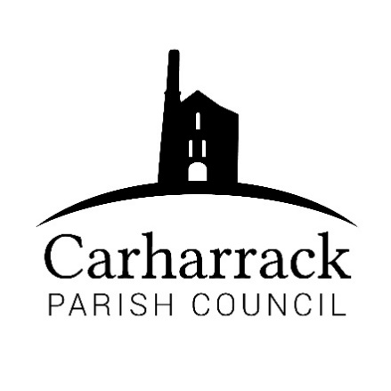 | Carharrack Parish Council
 | Parish Clerk: Joanna Picton
E: carharrackparishcouncil@gmail.com
W: www.carharrackparishcouncil.co.u
Ordinary Parish Council Meeting Minutes - 13th December 2021 (OM13/12)
7.00pm start held at the Mills Hall Carharrack

- Persons Present/Apologies: Chair Cllr Holland, Vice Chair Cllr Chown, Cllr Constable, Cllr Aldridge, Cllr Martin, Cllr Garbett. 1 Member of the Public. Apologies were received from Cllr Clarke, Mrs J Picton (Clerk) and CC Connor Donnithorne
- Chair welcome: Chair welcomed everyone to the meeting.
- Declarations of Interest: There were no Declarations of Interest
- Public Participation: Member of the public asked about the situation regarding the amenity area at Park Stenak. Raised issues of access, upkeep and non-use of the area in its current condition. Parish Councillors aware of the various issues relating to the site. The areas of responsibilty for both the immediate residents and its lack of accessibilty and use by the local community. Further discussion to follow during the course of this agenda and Parish Councillors agreed that the site needs improving, access agreed with all parties and better use for the residents of Park Stenak.
- Cornwall Councillors Report:
Report has been circulated to all Parish Councillors prior to the meeting. Regular reports from the interactive speeding sign would be welcomed. Cllrs Holland and/or Chown will attend the Community Network Panel in January. Parish Council are keen to see improvements to the Playing Field as and when policy allows.
- Parish Council Meeting Minutes for 26th October 2021 and 22nd November 2021 agreed as a correct record. Proposed by Cllr Chown, seconded by Cllr Constable. Signed by Chair. No matters arising
- The Pound
(a) Agreed for a free standing notice/information board. Local historian to be asked for text and any photographic images. Cllr Garbett to provide text relating to environment/wildlife and plans for this area. Reinstate the pond to encourage wildlife and a wildlife gardener/designer to be sourced to work with the Parish Council to improve the pond area. The intention is to create a natural area and not a “garden”. Contractor to work alongside the Parish Council and any able volunteers to complete the physical work.
(b) Land registration of The Pound is currently in the name of the former clerk. Proposed by Cllr Holland that this needs to be addressed and any costs incurred covered by the Parish Council. Seconded by Cllr Chown. No Objections.
- Park Stenak – After a brief discussion it was proposed by Cllr Holland and seconded by Cllr Aldridge that a letter is send to the builders of Park Stenak asking for the transfer of the ownership of the amenity area to Carharrack Parish Council at a fee of £1 plus any legal fees which are incurred. No objections
- Finance
(a) South West Water – Cllr Aldridge will obtain a meter reading and a request will be made for a revised invoice. Cllrs agreed to pay this upon receipt. Parish Councillors did not agree to the setting up of a direct debit.
(b) CALC – advised that training had taken place but an invoice had not been received in time for this meeting.
(c) Approval of salary payments, home working allowance and reimbursement for monthly website payment – Proposed by Cllr Chown and seconded by Cllr Aldridge. No objections
(d) Three quotes had been received for works to be carried out in the allotment site and the hedge on Sparry Lane. Proposed by Cllr Aldridge and seconded by Cllr Chown to accept the quote from Mark Wallcock. No objections
(e) Chair explained the difficulties with purchasing and improving the playing field without devolution. After discussion it was agreed to seek the making of a bespoke picnic bench for wheelchair/buggy access with a canopy. Proposed by Cllr Constable and sconded by Cllr Chown. Quotes to be brought to January meeting so that it can be made in readiness for the Spring/Summer.
(f) Due to an unclear conclusion to the discussion regarding a financial payment to the Mills Hall Trust for the use of the Mills Hall for Parish Council meetings it was proposed by Cllr Constable and seconded by Cllr Garbett that a payment of £500 is made. No objections
(g) Two quotes have been received for the removal of the ash tree on The Shute due to ash dieback disease. Proposed by Cllr Garbett and seconded by Cllr Aldridge to accept the quote from Greens.
Payments totalling £1,079.32 + revised invoice from South West Water were agreed for payment. Proposed by Cllr Chown and Seconded by Cllr Constable. No objections.
Authorisaton of payments to be made by Cllrs Chown and Constable.
- Planning Applications
PA21/02065 – Pre-application. No collective comments were made and Parish Councillors were informed and advised to put forward their own comments on this pre-application.
- Plastic Free Community
Carharack Parish Council agreed to support the St Day and Carharrack Plastic Free initiative. The Carharrack Parish Council Representative on the Plastic Free Steering Group will be Cllr Holland. The Parish Council will lead by example and phase out single-use plastics wherever possible and support all plastic free initiatives within the local area of Carharrack and St Day Date of Resolution: Monday 13th December 2021 Proposed by Cllr Chown and seconded by Cllr Garbett. No objections.
- Agenda Items for next Parish Council Meeting – to be advised to the clerk one week prior to the date of the next meeting.
There being no other business the meeting closed at 20:10hrs

